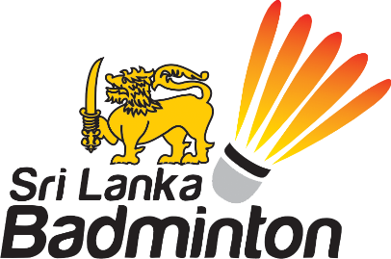

National Badminton Coach – Vacancy

With the departure of our Foreign National Coach, SLB is looking to select & appoint an outstanding local coach to this position until such time an International Coach can be sourced and appointed.
Basic Minimum Qualification for the position is BWF Level 1, 11, 111 or Level 1V Certification plus at least 05 years’ experience at a National or Senior (Provincial or Regional Level) within Sri Lanka or Overseas.
Candidates vying for this position must also have inspirational leadership qualities especially the roles of mentor & motivator in addition to an intimate knowledge of Physical Training, Skill Development, Badminton Techniques, International Standards, Foreign Match & Training Experience and most importantly, overall Player Development.
An attractive remuneration package and performance Incentives awaits the chosen candidate who will be offered a negotiable Term Contract with specific agreed KRA & KPI targeting international commitments & results.

Applications in writing with complete CV and testimonials should be submitted to:
CEO @ Sri Lanka Badminton, # 02, Cambridge Terrace, Colombo 07
on or before the 25 June 2020
Only selected candidates will be called for Interviews

