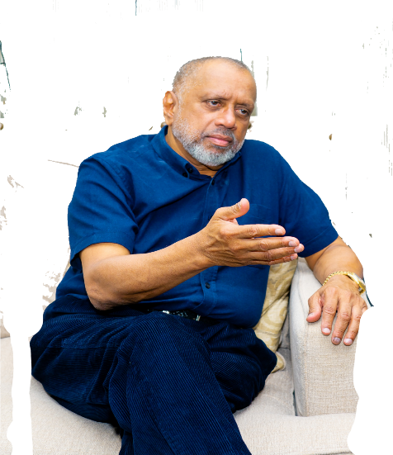

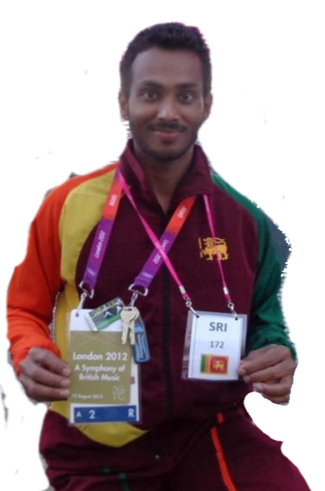
Open Communique

As President of Sri Lanka Badminton ,
it gives me great pleasure to congratulate
NILUKA KARUNARATNE for his exceptional success in
Qualifying to compete in the 20/21 Olympic Games in Tokyo in the Badminton Open
Singles Event vying for Medals.
I am so proud of NILUKA”s current accomplishments which started in 2019 participating in so many International Olympic Qualifying tournaments under difficult circumstances and collecting valuable points up to now which resulted in him successfully qualifying for the event .
The passion, drive and determination of Niluka Karunaratne is exceptional and inimitable.
Several others too were given the similar opportunity but were not successful, which highlights his commitment, hard work, efforts and performance which are also inspiration not only to young men and women who play the sport but also to all Sri Lankans.
Olympics provides us with a special opportunity and is an occasion to unite and network with international athletes and nations in so many ways and to be worthy Ambassadors of Sri Lanka in unique ways at OLYMPICS GAMES.
One of the thrilling aspects is the opportunity to cheer for a SRI LANKAN ATHLETE collectively irrespective of our communities joining together in seeing our country thrive in Badminton.
I offer my warmest congratulations and wish NILUKA KARUNARATNE the very best for every success in the Badminton Singles Open Event and eagerly await the opportunity to cheer on our dear acclaimed Athlete with the hope and aspiration of Winning a Medal for Sri Lanka!!
God bless him!

Rohan De Silva
President
Sri Lanka Badminton

