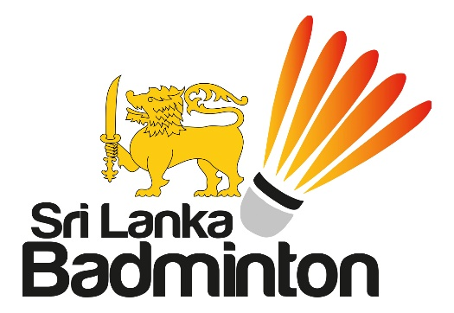

07 June 2021

M E M O R A N D U M
To: National Pool Players – Seniors & Juniors
CC: National Pool Coaches
You will see in attachment the List of Senior & Junior National Pool Players
that have been selected for future training & preparation for International Competitions.

The SLB website also carries the Selection Criteria for the National Pools as well as the National Teams. The Code of Conduct (CoC) is also ready and will be issued to you when you are summoned.

No sooner government travel restrictions are relaxed we will summon you for the training schedules that are being prepared by the National Coaches and begin preparations. Until then, we urge you to remain fit by following our virtual sessions.

Should you require any information in this regard, please feel free to contact the undersigned or the CEO as per the mobile ID’s 0773 593 780 or 0772 772 001.

Stay Fit. Stay Safe.

Chairman – SLB NPTC

