COMMONWEALTH GAMES PRELIMINARY TRIALS: 14th – 17th January 2022 at MBA courts
SPECIAL NOTE
- Trials on 14th January 2022 will be for MS, WS only. Players invited for MS & WS trials should report at 8.00 am at MBA Courts.
- Trials for MD, WD will commence on 15th January 2022 in the afternoon. Players invited for MD & WD should report at 12 noon at MBA courts.

- The shuttlecocks to be used for trials is Ling-mei.
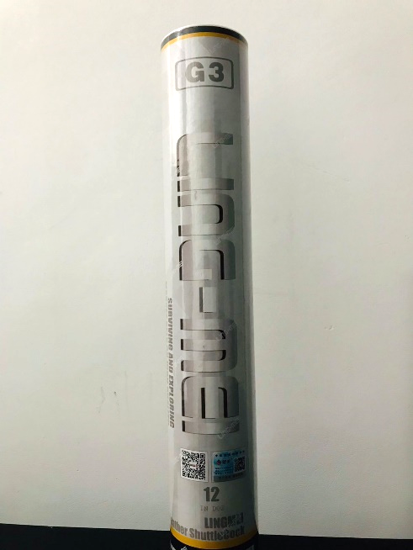
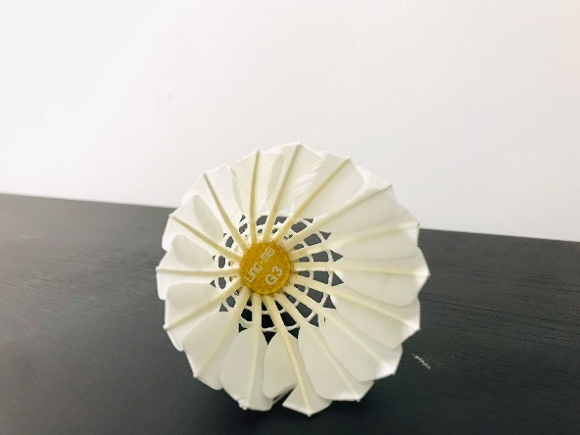
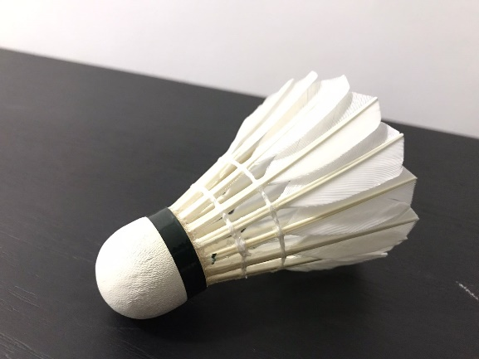

Selection committee

