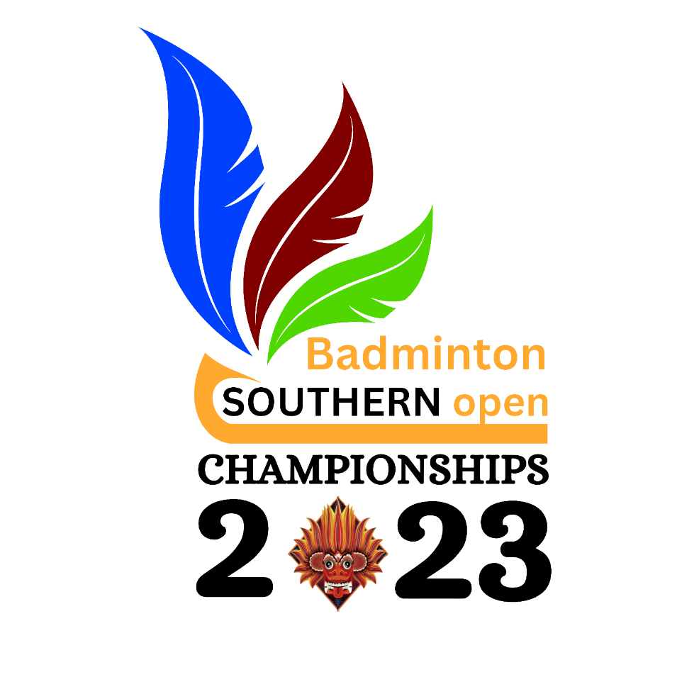

Organized by
Southern Province Badminton Association
Affiliated to
Sri Lanka Badminton

From

06th – 11th March 2023
AT

Ambalangoda
Galle
Matara

Prospectus

SPBA Open
All Island Open Badminton Championships 2023
National Ranking Level - 1

Organizer | Southern Province Badminton Association (SPBA)  Sri Lanka Badminton (SLB)  Maitland Place, Colombo 07, Sri Lanka  Tel : +94 11 268 6264  Email: southernopen2023@srilankabadminton.lk
Dates | 06th (Monday) – 11th (Saturday) March 2023
Venue | Dharmashoka College Indoor Stadium, Ambalangoda,  Dadalla Indoor Stadium, Galle / Indoor Stadium, Matara
Key Dates | Entry closing date Thursday 2nd March 2023  M & Q Publish Date Friday 3rd March 2023  Main Draw Seeding – SLB Ranking date Sunday 4th March 2023  Seeding Report publish date Sunday 4th March 2022  Last date for withdrawals without penalty Before 9.00 am Tuesday, 5th March 2023  Draw 11.00 am Tuesday 5th March 2023  The Draw will take place on 11.00 am Tuesday 5th March 2023 at SLB Conference Room  The Draw will be conducted on BWF tournament software and could be viewed live, on the SLB FB page and SLB website.  The Draw shall be published on the SLB web ( www.srilankabadminton.lk ) and Facebook https://www.facebook.com, https://youtube.com / channel  Seeding shall be done by SLB and approved by the Referee.  The last date for withdrawal of entry into any event, without penalty, shall be the 5th March 2023. Such withdrawals should be notified in writing to the SLB, addressed to the Secretariat email: southernopen2023@srilankabadminton.lk; and an acknowledgment obtained. If no acknowledgement is received with 24 hours, SLB should be contacted. Any withdrawal after the draw is published, shall carry a penalty of Rs. 5,000.00. If the player fails to pay the penalty by due date, he/she will not be allowed to participate in future SLB sanctioned tournaments for a maximum period of Twelve (12) Months. The due date will be 14 days after the conclusion of the tournament.  * All Documents are found in SLB Website: www.srilankabadminton.lk  *Send ONLY the payment slop with the player’s name to Email ID: southernopen2023@srilankabadminton.lk
Entries | Entry Forms are available on the SLB website. www.srilankabadminton.lk ;  Age will be calculated as of 01st January 2024 for Junior Events (Under 11/13/15/17 and 19) events.  Age will be calculated as of 01st January 2023 for all Senior Events and Over 30 events.  All participants for Open Events should be above 14 years of age as of 01 January 2023.  BWF Rules are applicable for Senior Events.  A player can compete in not more than one singles, one double, and one mixed doubles event in any eligible age group. Ex: A male player eligible in the 45+ age category, can enter in 45+ Men’s Singles, then he will not be eligible to play in Men’s Singles event in any other age group. He can, however, play in Men’s doubles or mixed doubles in another age category or in the same age category.  All Entry Fees should be paid at the time of submitting the entry or before. All Cheques should be drawn in favor of “Sri Lanka Badminton Association” & crossed “Account Payee Only” or cash deposited in the SLBA  Account Number 0002323122 at Bank of Ceylon, Torrington Branch – Colombo - 07 and the deposit slip sent to the email ID: southernopen2023@srilankabadminton.lk  Entries without entry fees will be rejected.  Entry Fees will not be refunded unless event cancelations are made by the Organizers.  The entry list (M&Q) will be published on SLB Website from Friday, 3rd March 2023.  All players should check the list and contact the Tournament Referee if there are errors or any amendment or adjustment that is needed before 9.00 AM on 5th March 2023  Players are advised to submit entries ON-LINE to the Link: https://www.tournamentsoftware.com/tournament/714E9A77-FFE6-4CAC-88A2 8BC942C5F04C AND EMAIL THE PAYMENT SLIP TO southernopen2023@srilankabadminton.lk; with the name of the player.  In Doubles Event the doubles partner should also enter the double event separately when applying.  The closing date for the entries received to the on line link shall be Thursday, 2nd March 2023 at 23.59 hours at the SLB office.  1. All entries submitted after the closing date as well as entries with any technical errors shall be rejected.  2. No substitution or amendments to the entries shall be permitted other than for withdrawal of entries after the release of the M & Q report  For players who are having technical difficulties, please email: southernopen2023@srilankabadminton.lk  for enquires, phone Mobile ID 0777996699 for any assistance required, prior to the closing date provided.  If no objections are received by SLB before 23.59 hours on the 3rd March 2023, the entries shall be deemed to be correct. Complaints/Objections shall not be entertained thereafter.  PLEASE NOTE THAT ENTRIES SENT TO OTHER THAN the ON-LINE LINK PROVIDED, https://www.tournamentsoftware.com/tournament/714E9A77-FFE6-4CAC-88A2-8BC942C5F04C shall not be accepted.  All Players must enter the Date of Birth and all relevant details required in the Entry Form when submitting the entry and shall produce the NIC, Passport or Birth Certificate when requested by the Referee and/or Tournament Organizing Committee.
Tentative Timetable | Day Date Start Time Program  Sunday 05th March 2023 17.00 Hours Technical Officials Briefing  Monday 06th March 2023 08.00 Hours Opening Ceremony / Preliminary Rounds  Tuesday 07th March 2023 08:00 Hours Preliminary Rounds  Wednesday 08th March 2023 08:00 Hours Preliminary Rounds  Thursday 09th March 2023 08:00 Hours All Pre-Quarter Finals / All Quarter Finals  Friday 10th March 2023 08:00 Hours All Semi-Finals  Saturday 11th March 2023 08:00 Hours All Finals /Closing Ceremony  * Changes to the Timetable for any reason, shall only be at the discretion of the Referee.  *All events are as per the time table system; Matches will be forfeited if the player/s is/are not present at the time of play when the match is scheduled. However, a ten (10) minute grace period shall be allowed. No postponements shall be allowed, under any circumstances.
Events | Event Category  Open MS/WS/MD/WD/XD  Junior U11/U13/ U15/ U17/ U19 BS/GS/BD/GD  Non- Senior Over 30 MS/WS/MD/WD/XD  Senior Over 35/ 40 +/ 45 +/ 50+/ 55+ /60+ /65+ /70+ MS/WS/MD/WD/XD  The Tournament Committee shall cancel an event in the Tournament if there are less than four (4) entries. However, for Senior events, if there are less than (4) entries for an event, the Tournament Committee shall amalgamate these entries into the next lower age group only, subject to players’ consent.  If over 30 age group has less than 4 entries, the event will be cancelled or amalgamated in to the OPEN event subject to players consent.
Format of Play | The Tournament shall be conducted on a knock out basis  Rally Point System: best of 3 x 21 points, U11 / U 13 events: best of 3 x 15 points  Play will be in accordance with the Laws of Badminton as mentioned on the web site of BWF and SLB.Tournaments Regulations / General Competition Rules will be according to BWF as adapted by SLB.  All players and officials shall be subject to the Players Code of Conduct of BWF & SLB.
Prize Money & Medals | Prize Money Offered for the Championship is Rs. 500,000.00 only for Open Events based on the number of Entries for the Open Events and according to Tournament Policy.  And Certificates & Trophies/Medals/Plates will be awarded to all Winners, Runners-Up & Semi-Finalists of the Tournament based on the number of Entries,  No of Entries Winner Runner Up Semi Final  4 ≤ 7 1 1  8 ≤ 15 1 1 2  16 ≤ 1 1 2  Award Presentation:  During the Award Ceremony, players should wear tracksuits/ sportswear. ( No sandals or slippers permitted)
Shuttles | Feather shuttlecocks of a Li Ning brand shall be used for all the events except U 11/ U 13 where Nylon shuttles will be used. However, the Referee shall have the right to decide on any change, under a force majeure situation.
Competition  Rules & Regulation | Relevant Badminton World Federation Regulations as adapted by SLB, shall be applicable to this competition.
Clothing & Advertising | Clothing and advertising will be permitted in accordance with the tournament regulations of Badminton World Federation. (GCR 20 - 24)  For players who have signed the Code of Conduct of SLB, clothing, shoes and equipment shall be as provided by LiNing, unless otherwise exempted to so by the President of SLB, in writing.  It is recommended that, the player’s name on the back of clothing shall be identical with the name registered as the Last Name (or an abbreviation thereof) in the BWF/ SLB Player database. Last Name is defined as the family name, surname or similar name under the respective naming protocol. (GCR 23.3)  MANDATORY AND RECOMMENDED CLOTHING REGULATIONS  - Open Events, Mandatory from Quarter Finals onwards:  - Name of the player,  - Double partners must wear clothing of the same colour.  - Opposing players must wear clothing of significantly different colors.  - Other Events Name of the player is recommended from Quarter Finals onwards
Medical Team | Medical Team/ Physiotherpy, will be on duty throughout the tournament at the tournament Venue.
Doping Control | Doping control in badminton, in accordance with BWF Anti-Doping Regulations, is conducted out-of-competition and in-competition with the collection of urine and/or blood samples.  Athletes are responsible for any substance found in their body. Before an athlete takes any medication, they should check with their doctor, and if necessary, get a Therapeutic Use Exemption (TUE).  For more information about anti-doping, please visit the BWF website: https://corporate.bwfbadminton.com/integrity/anti-doping-overview/
Badminton Integrity | Section 2.4 of the BWF Statutes (Code of Conduct in Relation to Betting, Wagering and Irregular Match Results) and the Constitution of SLB, and Code of Conduct of SLB, relates to anti-corruption and anti-match manipulation, and this code applies to all participants at this tournament.  To protect the integrity of SLB tournaments, participants are not allowed to bet in any way on badminton matches, respect the principle of fair play, and shall not attempt to influence the course or result of a game or match.  Every person has an obligation to report to the SLB any approaches by anyone to gather inside information or to change the outcome of a matches.
Compliance with SLB Regulations | In submitting the entry the Competitor concerned accepts the SLB regulations, Code of Conduct and Disciplinary Processes, which shall be final and binding.
TO’s Briefing | 05th March 2023(Sunday) at 17:00 Hours  Venue: Dadalle Indoor Stadium, Galle
Referee | Mr.Sanjeewa Wijesekara  Email: sanjeewabac@yahoo.com  Phone: 0710891691
Deputy Referee(s) | Ms.Samantha Nawarathne  Email: sknawarathne@yahoo.com  Phone: 0773227604 | Assistant  Referee | Mr. Akila Hettiarachchi  Phone: 0771851839
Chairman Organizing Committee | Name: Mr. Wasantha Kumara, President, SPBA  Email: beruwalage1971@yahoo.com  Mobil: 0777938353
Organizing Committee Secretary | Name: Mr. D. Buddika de Silva, Secretary, SPBA  Email: spbaambalangoda@gmail.com  Mobil: 0774866621
Tournament Director | Name: Mr. Padula Sri Rohana de Silva  Email: paduladesilva@yahoo.co.uk  Mobil: 0714899611
Head of Tournament Committee | Name: Lakshmi Punchihewa  Email: lakshmi_liyanage@yahoo.com;  Mobil: (077) 774 3814
IT Admin | Name: Ameen Hilmy Nawas  Email: it@srilankabadminton.lk ;  Mobil: 0769114493/0781600606
Contacts | For any further clarification / assistance, please contact:  Mr. D. Buddika de Silva Mobil: (077) 486 6621 Mrs. Lakshmi Punchihewa Mobil: (077) 774 3814 Mr. Padula de Silva Mobil: (071) 489 9611  Mr. Iresh de Silva Mobil: (077) 824 1166 Mr. Dervian Priyankara Mobil: (071) 018 8574 Mr. G. Eddirisooriya Mobil: (071) 815 2370
COVID 19 Protocols | - Please note that this tournament will be conducted strictly according to Health Ministry guidelines & Sports Ministry instructions relating to COVID 19. All competitors and officials are expected to follow these procedures without exception. Failure to do so may result in immediate disqualification by match officials”
Indemnity & Insurance | Any player / officials agree to indemnity and not hold the SLB and the Organizers of the Tournament, accountable for and against any claims for personal injury, financial loss, death or property damage, in any form, arising out of or in any way resulting from the participation in, postponement or cancellation of the said tournament.  SLB shall NOT be responsible for any injury sustained, at any time, by any player or official arising from his participation in these Championships. Any costs incurred for medical treatment and / or hospitalization shall be borne by the player / official concerned.  Players & officials should possess the requisite insurance coverage to meet any of the liabilities discussed above.
*Special Notice* | *If a player concedes a walkover in any event due to injury/illness or absence, he/she will not be permitted to compete in any other event of the tournament. (This does not apply to senior events.)  *Substitution is not allowed for the championships except in events over 30 and above (Senior Event)  In Senior Events, a competitor will be permitted to substitute a partner if the original partner (affected player) is prevented from playing through illness, injury or other unavoidable hindrance. The affected player will not be allowed to play in any other event on that day. Such proposed substitute shall be notified to the Tournament Referee in writing, before the commencement of that particular event. Such substitution shall not be of a higher rank than the affected player. The substitute player should not have entered the same event separately.
Match Referee | The Referee shall be in overall charge of the technical details and the conduct of the tournament and the Referee’s decision shall be final and binding  The decision of the umpire shall be final on any point of fact in the match of which he/she is umpiring and shall not be questioned.  All disputes with regard to the technical details of the Tournament shall be referred to the Referee or any administrative matters relating to the conduct of the tournament to the Tournament Committee depending. On all matters connected with the conduct of the tournament and on any administrative matters not provided for, the decision of the Tournament Committee shall be final and binding on all participants.

Southern Open

All Island Badminton Championships – 2023
Organized by Southern Province Badminton Association affiliated to Sri Lanka Badminton

Entry Form
USER NAME

SLBA Registered No |  |  | BWF NO:
MALE |  | Date of Birth | DD | MM | YY | NIC No
FEMALE

No. | Event | Entry Fees Rs. | Born on or after | Mark  “X” | Mandatory Information for Entry in the Tournament Planner.  District of Birth:  Name of Club/District:  …………………………………………………..  If not attached to a Club or District, please specify as N/A
01 | Under 11 Boy’s Single | 3500 | 2013.01.01
02 | Under 11 Girl’s Single | 3500 | 2013.01.01
03 | Under 13 Boy’s Single | 3500 | 2011.01.01
04 | Under 13 Girl’s Singles | 3500 | 2011.01.01
05 | Under 15 Boy’s Singles | 3500 | 2009.01.01
06 | Under 15 Girl’s Singles | 3500 | 2009.01.01
07 | Under 17 Boy’s Singles | 3500 | 2007.01.01
08 | Under 17 Girl’s Singles | 3500 | 2007.01.01
09 | Under 19 Boy’s Singles | 3500 | 2005.01.01
10 | Under 19 Girl’s Singles | 3500 | 2005.01.01
No. | Event | Entry Fees Rs. | Born on or after | Mark  “X” | Double Partner’s Name | Date of Birth | Signature
11 | Under 11 Boy’s Doubles | 4500 | 2013.01.01
12 | Under 11 Girl’s Doubles | 4500 | 2013.01.01
13 | Under 13 Boy’s Doubles | 4500 | 2011.01.01
14 | Under 13 Girl’s Doubles | 4500 | 2011.01.01
15 | Under 15 Boy’s Doubles | 4500 | 2009.01.01
16 | Under 15 Girl’s Doubles | 4500 | 2009.01.01
17 | Under 17 Boy’s Doubles | 4500 | 2007.01.01
18 | Under 17 Girl’s Doubles | 4500 | 2007.01.01
19 | Under 19 Boy’s Doubles | 4500 | 2005.01.01
20 | Under 19 Girl’s Doubles | 4500 | 2005.01.01
Mandatory Information for entry in the tournament Planner
Partner SLBA Registered No……………………….
District of Birth: …………………………………….
Name of School: …………………………………………………………………………

Southern Open
All Island Badminton Championships – 2023
Organized by Southern Province Badminton Association affiliated to Sri Lanka Badminton

Entry Form

USER NAME

 | SLBA Registered No |  |  |  |  | BWF NO:
 | MALE |  |  | Date of Birth |  | DD |  | MM | YY |  |  | NIC No
 | FEMALE
No. |  | Event |  |  | Entry Fees (Rs.) |  | Mark” X”
1 |  | Open Men’s Singles |  |  | 6,000.00
2 |  | Open Women’s Singles |  |  | 6,000.00
3 |  | Open Men’s Doubles |  |  | 8,000.00
4 |  | Open women’s Doubles |  |  | 8,000.00
5 |  | Open Mixed Doubles |  |  | 8,000.00

Event | Double Partners Name | SLB NO | Signature
Men’s Doubles
Women’s Doubles
Mixed Doubles

Mandatory Information for entry in the tournament Planner
District of Birth: …………………………………….
Name of School: …………………………………………………………………………
Name of Club/District: …………………………
**If not attached to a Club or District, please specify as N/A
Phone Number/s: …………………………………...
E Mail: …………………………………………………….
Signature……………………………………………….

Southern Open
All Island Badminton Championships – 2023
Organized by Southern Province Badminton Association affiliated to Sri Lanka Badminton

Entry Form

USER NAME

Please write your name within the 12 boxes as you require the registration to be made

SLB Registered No |  |  | BWF NO:
MALE |  | Date of Birth | DD | MM | YY |  | NIC No
FEMALE

No. | Event | Entry Fees Rs. | Born on or before | Mark  “X” | Mandatory Information for Entry in the Tournament Planner.  District of Birth:  Name of Club/District:  …………………………………………………..  If not attached to a Club or District, please specify as N/A  Phone Number/s:  Mobile: ..........................................................  Land Line: .....................................................  E Mail: ………………………………………......  ……………………………………………………
01. | Over 30 Men’s Singles | 5000 | 1993.01.01
02. | Over 30 Women’s Singles | 5000 | 1993.01.01
03. | Over 35 Men’s Singles | 5000 | 1988.01.01
04. | Over 35 Women’s Singles | 5000 | 1988.01.01
05. | Over 40 Men’s Singles | 5000 | 1983.01.01
06. | Over 40 Women’s Singles | 5000 | 1983.01.01
07. | Over 45 Men’s Singles | 5000 | 1978.01.01
08. | Over 45 Women’s Singles | 5000 | 1978.01.01
09. | Over 50 Men’s Singles | 5000 | 1973.01.01-
10. | Over 50 Women’s Singles | 5000 | 1973.01.01
11. | Over 55 Men’s Singles | 5000 | 1968.01.01
12. | Over 55 Women’s Singles | 5000 | 1968.01.01
13. | Over 60 Men’s Singles | 5000 | 1963.01.01
14 | Over 60 Women’s Singles | 5000 | 1963.01.01
15. | Over 65 Men’s Singles | 5000 | 1958.01.01
16 | Over 65 Women’s Singles | 5000 | 1958.01.01
17 | Over 70 Men’s Singles | 5000 | 1953.01.01
18 | Over 70 Women’s Singles | 5000 | 1953.01.01

No. | Event | Entry Fees Rs. | Born on or before | Mark  “X” | Double Partner’s Name | Date of Birth | Signature
19 | Over 30 Men’s Doubles | 7500 | 1993.01.01
20 | Over 30 Women’s Doubles | 7500 | 1993.01.01
21 | Over 30 Mixed Doubles | 7500 | 1993.01.01
22 | Over 35 Men’s Doubles | 7500 | 1988.01.01
23 | Over 35 Women’s Doubles | 7500 | 1988.01.01
24 | Over 35 Mixed Doubles | 7500 | 1988.01.01
25 | Over 40 Men’s Doubles | 7500 | 1983.01.01
26 | Over 40 Women’s Doubles | 7500 | 1983.01.01
27 | Over 40 Mixed Doubles | 7500 | 1983.01.01
28 | Over 45 Men’s Doubles | 7500 | 1978.01.01
29 | Over 45 Women’s Doubles | 7500 | 1978.01.01
30 | Over 45 Mixed Doubles | 7500 | 1978.01.01
31 | Over 50 Men’s Doubles | 7500 | 1973.01.01
32 | Over 50 Women’s Doubles | 7500 | 1973.01.01
33 | Over 50 Mixed Doubles | 7500 | 1973.01.01
34 | Over 55 Men’s Doubles | 7500 | 1968.01.01
35 | Over 55 Women’s Doubles | 7500 | 1968.01.01
36 | Over 55 Mixed Doubles | 7500 | 1968.01.01
37 | Over 60 Men’s Doubles | 7500 | 1963.01.01
38 | Over 60 Women’s Doubles | 7500 | 1963.01.01
39 | Over 60 Mixed Doubles | 7500 | 1963.01.01
40 | Over 65 Men’s Doubles | 7500 | 1958.01.01
41 | Over 65 Women’s Doubles | 7500 | 1958.01.01
42 | Over 65 Mixed Doubles | 7500 | 1958.01.01
43 | Over 70 Men’s Doubles | 7500 | 1953.01.01
44 | Over 70 Women’s Doubles | 7500 | 1953.01.01
45 | Over 70 Mixed Doubles | 7500 | 1953.01.01

Mandatory Information for entry in the Tournament Planner
District of Birth: …………………………………….
Name of School: …………………………………………………………………………
Name of Club/District: …………………………
**If not attached to a Club or District, please specify as N/A
Phone Number/s: …………………………………...
E Mail: ……………………………………………………

